Early History Timeline of the Littleton Garden Club from handwritten minutes

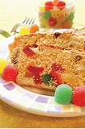
1938
15 members including Anna Pennock.
Used women’s first name in first page of minutes.
Dues 1 dollar a year. Meet monthly year round.
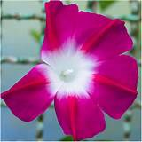
S
pent $1.25 on lilac President Poincare var. for UNH lilac arboretum. Gumdrop cake served with tea at Xmas 38 meeting Roll call responses: favorite houseplant, what’s new in seed catalogs…1939 Jan- Scarlet Ohara morning glory variety new in catalog.

1939
Pennock used gavel made from one of her apple trees.
April 1939 first time used community house for meeting.
Doubled membership in first year.
Years begin in June Had birthday cake with one candle.
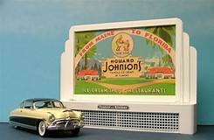
July 39 : Masonic temple. Admission 25 cents. Public and WMGC sold garden stamps ($19.50) and had presenter and piano music. 37 members. Pennock asked members to consider themselves a committee of one. Ragweed eradication. Nov 39 Discussed protesting billboard advertising.
Dec. 39 movie reel in color showing Florida trees and flowers.

1940
Jan: cookie and mints served.
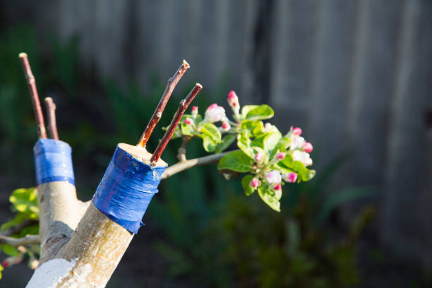
Feb: idea of using glazed pot instead of clay tile that draws moisture. Colored slides of grafting by UNH speaker,
Special meeting at Thayers hotel
April :paid for sending 2 HS senior boys to UNH for 4 day hort course and to report back.
July: Cattail pollen for pancake making in talk 40 members at 2nd year.

1941
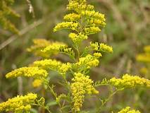
8 different boys employed for ragweed elimination on Saranac St., South &
Bridge streets @ 65 hrs a wk.Members may bring guests more than once but by paying a guest fee of 15 cents.
Program- war gardens Victory garden committee.
Prize of one dollar in defense stamps to best poster for victory garden committee.
Time given at meeting for red cross work.
End of 4th year- Miss Bingham served lemonade and ginger cakes.
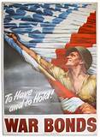

1942
Nov: Discussed buying war bond and doing more red cross work.
Meeting on Littleton teacher encouraging saving canceled stamps.

1943
Tribute to Miss Helen Bingham after her death.
February: One dollar war relief seeds for England to feed a family of 5 with vegetables for a year.
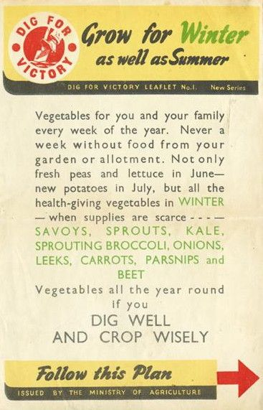
Anna Pennock retired as president. “ Gardens make ammunitions too” slogan adopted.
Scrapbooks started.

1944
UNH victory garden programs and appeals from the red cross.
Boston flower show program (only one held in the US that year).
Victory flower show with no admission charge in August at Community Center.
Ragweed program continues/ 763 lbs. Collected by youth.
Franconia Chemical Gardens speaker at meeting- new way of chemical gardening for post war.

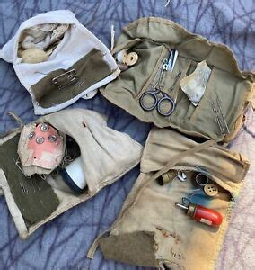
1946 Raised $ for flowers for Army and Navy hospitals. Donations to Portsmouth VA hospital.
More billboard restriction discussion. Red Cross appeals for help with fundraising.
Sewing kits for soldiers as well as magazines donated to VA hospital.

1947
Plans to deal with eyesore of cottage street bridge river bank but tabled as new bridge coming.
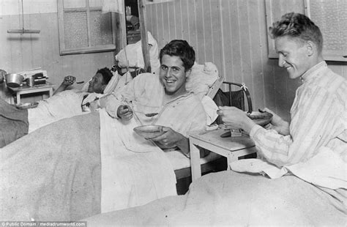
Christmas greens and trays readied for soldiers at VA at Christmas.

1948
Wartime experiments with chemicals lead to program (Lowe brothers chemicals) on new types of household chemicals/ sprays and paints,Chemicals developed to spray on Japan. After atomic bomb, research abandoned.
“Seeds for Peace”project, 50 cents per packet to /Europe to raise own veg, instead of wheat.
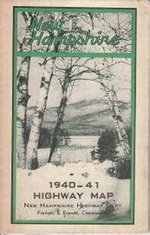
Soldier talk/travelogue program, Roadside trash concerns.“End O pest” and “End O weed” products promoted in programs.
¹⁰th anniversary. Mentioned the red cross stockings. Club has 65 members.
Bought black out curtains for community center to better watch movies, slides.

1949
School clean highway poster projects. Posters displayed in store windows.
Written by Mary A Bingman 3/2024

