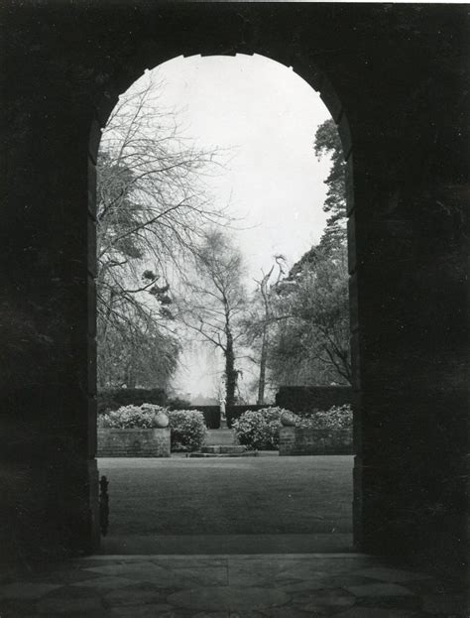
The Colonial Club and it’s relationship to the Littleton Garden Club
The Colonial Club- a service club of women, preceded the Littleton Garden Club.
They were affiliated with the NH Federation of Women’s Clubs.
From that source, Littleton Garden club was started.

The group started in 1894 with the goal to be community minded. They offered socialization, organized theatrical and musical events. Heavy civic involvement including landscaping and community programs continued throughout the group’s100 years.

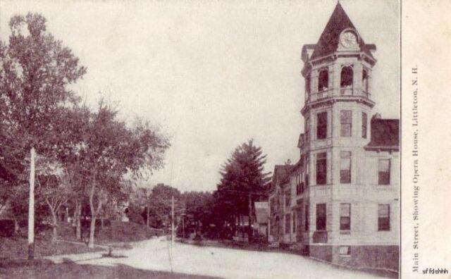
One large project was the renovation at the Littleton opera house
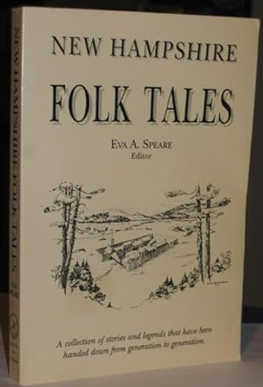

Many famous people were involved with the group including Eva Augusta Spear
(author of New Hampshire folk tales).
She was known at the time as Mrs. Guy E. Spear. The use of the husband’s name for females was common then. Women used their first names in the handwritten minutes of the Colonial Club. Her book (pictured) is available at the Littleton Public Library.

Robert Frost was a featured speaker in one of the early meetings of the Colonial Club.
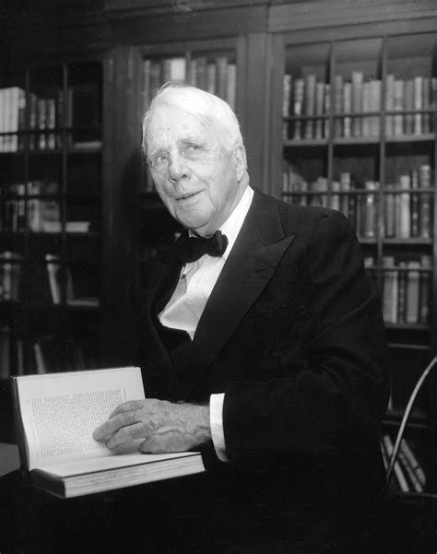

Some unique traditions were a part of the organization. In the early 1900’s the roll call at each meeting began with a particular response. Instead of answering: “present”, each member responded with a quotation on a subject chosen by the president from the previous meeting.
“You can bury any number of headaches in a garden”

- Charles Barnard (1889)

The Colonial Club was disbanded in 1994 at the time of their 100th year as a group.
Declining membership was cited. They donated their monies evenly between the Littleton Community Center and the Littleton area Historical Society.

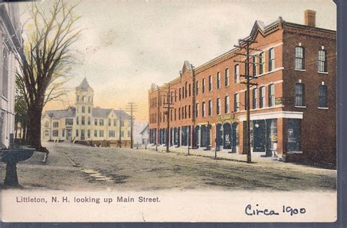

Written by Mary A. Bingman 3/2024

